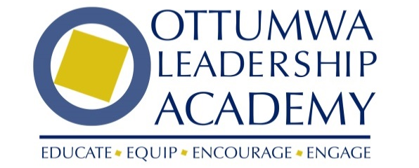

2024-25 Applicant Employer Acknowledgement Form
Completion of this Employer Acknowledgement Form is required for an applicant to be considered for class participation. All information is confidential. Class size is limited. Participants are selected based on leadership potential and demonstrated community interest. Candidates who are not selected are encouraged to apply again for future classes.

Email completed form to: htometich@leadottumwa.org or mail to 111 East Main Street
Deadline: June 30, 2024

Applicant Name: _____________________________________________________
Current Employer: ____________________________________________________
Title: _______________________________________________________________

Acknowledgement by Employer
The undersigned, as the Employer of the applicant acknowledges:
- That it consents to applicant’s participation in the Leadership Academy, in the event applicant is accepted into the program.
- That as the employer, it will cooperate with the applicant and the Leadership Academy during the term of the program, including accommodation, where possible, of applicant’s work schedule to permit attendance and participation in the monthly sessions and class projects as well as mandatory attendance at the Opening Retreat on September 20 & 21, 2022, final session and graduation on June 5, 2025.
- That any fees paid by employer for applicant’s participation are non-transferable and non-refundable in the event that applicant does not complete or is discharged from the program

Employer Signature: __________________________________________ Date: ______________
Employer Printed Name: __________________________________________ Title: ____________

